**ASSIGNMENT 8.2**

**PROBLEM STATEMENT:**

1. Find the number of students who scored less than 5(50%).

**Step 1:** load the data using the pigstorage as shown below



**Step 2:** perform filter ,group and foreach generate the count required

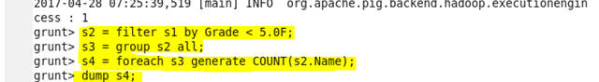

**Step 3:** output required

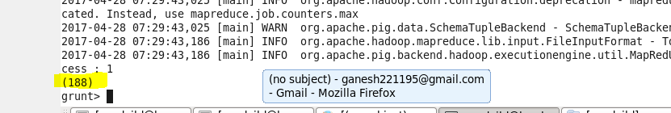

1. List the name of students who are from Alaska.

**Step 1:** load the required data into the platform using pigstorage



**Step 2:** perform the filter, group and for each generate flatten range



Step 3: output generated

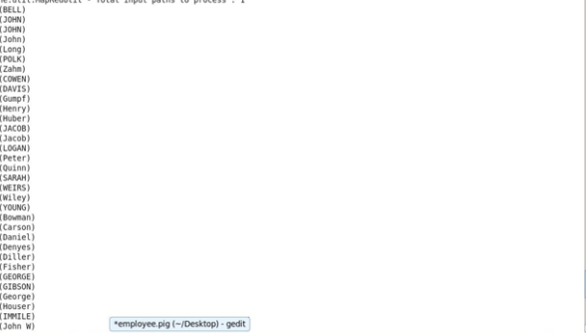

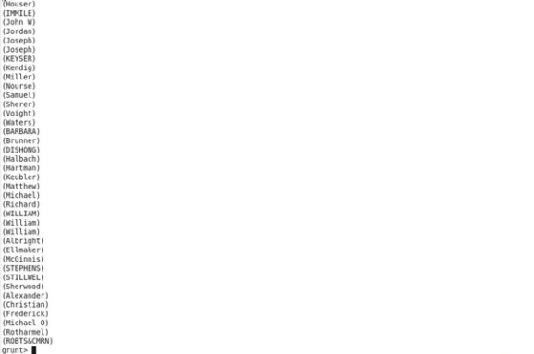

1. How many government colleges are there in Alabama?

**Step 1:** after loading of data perform filter,groupby and foreach operations

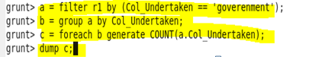

**Step 2: Output required**

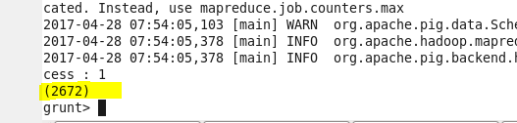

1. List the name of students who are from Oregon and pursuing BE.

**Step 1: :** after loading of data perform filter,groupby and foreach operations

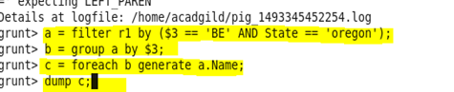

**Step 2: Output required**

